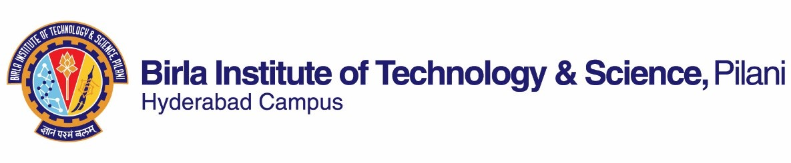

# SECOND SEMESTER 2022-2023

Course Handout Part II

Date: 16-01-2023

In addition to part-I (General Handout for all courses appended to the time table) this portion gives further specific details regarding the course.

*Course No.* : AN F314

*Course Title* : Introduction to flight

*Instructor-in-Charge* : Dr. Jayaprakash K S

# Course description:

This is an introductory course on the essentials of flight covering most of the topics necessary for detailed study if one is interested in future. This course aims at providing an insight into the fundamentals of aerospace engineering at the introductory level, including the key concepts of basic aerodynamics, aircraft performance and testing, flight stability and control, aircraft materials and design consideration, and an initiation to advanced concepts.

# Scope and Objective of the Course:

Students taking this course should be able to delve deeper into topics related to aircrafts, aerodynamics, and flight.

* Modelling of the Earth’s atmosphere for aircraft design
* The fundamental aerodynamic concepts for flying an aircraft
* Generation of lift by air foils and wings
* Aircraft’s optimal climb, cruise and descend rate
* Methods of flight test
* Basic aircraft structural design from the concepts of mechanics of solids

# Textbooks:

TB 1: Introduction to Flight, John D. Anderson, 6th Edition, McGraw Hill, (Special Indian edition) 2017 TB 2: Aircraft structures for engineering students, T. H. G. Megson, Elsevier India, 2005

# Reference books

1. Ojha S.K., Flight Performance of Aircraft, AIAA Education Series, 1995
2. McCormick, B.W. Aerodynamics, Aeronautics, and Flight Mechanics. New York: John Wiley and Sons, 1979

# Course Plan:

|  |  |  |  |
| --- | --- | --- | --- |
| **Lecture No.** | **Learning objectives** | **Topics to be covered** | **Chapter in the Text**  **Book** |
| 1-4 | Fundamentals concepts | Components of an aircraft, Types of aerial vehicles.  Properties of atmosphere: ISA, IRA, Pressure altitude, Altimeter; Aircraft speeds | Ch. 1, 2, 3 |
| 5-7 | Basic  Aerodynamics | Fluid dynamic equations & their basis, Ideal fluid, viscous flows, compressibility, wind tunnels | Ch. 4 |

|  |  |  |  |
| --- | --- | --- | --- |
| 8-12 | Air foils and Wings | Flow past a body, Flow Separation, Generation of Lift, Drag & Moment, Non-dimensional coefficients, Air  foils & Wings, Aero foil families, Supersonic flight | Ch. 5 |
| 13-19 | Airplane Performance | Drag, Thrust and Power Requirements, Rate of Climb, Steady, Level Flight, Gliding Flight, Range and Endurance, Take-off and Landing Performance, Turning  Flight and V-n Diagram, UAVs, and MAVs | Ch. 6 |
| 20-26 | Stability and Control | Moments, Static stability and control, Pitching Moment, Neutral Point, Static Margin, Directional and Lateral  Statics, dynamics, and control | Ch. 7 |
| 27-33 | Structures and  Materials | Physics of solid materials, Aircraft Materials, Flight  loads, Bending, and Fatigue | Part B (TB 2) |
| 34-36 | Advanced concepts | Concepts of aeroelasticity, Space flight, unsteady aerodynamics | Ch. 8 (TB  1)  Handouts |

**Evaluation Scheme:**

|  |  |  |  |  |
| --- | --- | --- | --- | --- |
| **Component** | **Duration** | **Weightage (%)** | **Date & Time** | **Nature of Component** |
| Quizzes# | 40 min | 20% | Unannounced | OB* |
| Mid semester Test | 90 min | 25% | 17/03 4.00 - 5.30PM | CB |
| Seminar (individual) | 40 min | 15% | TBA | OB |
| Comprehensive Exam | 180 min | 40% | 18/05 AN | CB |

# Three unannounced quizzes will be conducted, and the two best scores will be taken for evaluation

* Only prescribed textbook(s) and handwritten notes are permitted

**Chamber Consultation Hour:** Wednesday 5 pm to 6 pm. Other weekdays with prior appointment. **Notices:** All notices concerning this course shall be displayed on the CMS (the Institute’s web-based course management system). Students are advised to regularly visit CMS for latest updates.

**Make-up Policy:** Make ups are not given as a routine. It is solely dependent upon the genuine medical or health circumstances with proper documentary evidence under which a student fails to appear in a scheduled evaluation component. In such circumstances, prior permission should be obtained from the Instructor-in-Charge (I/C). Students with less than 70% of attendance will not be allowed to avail the make-ups. The decision of the I/C in the above matter will be final.

**Academic Honesty and Integrity Policy:** Academic honesty and integrity are to be maintained by all the students throughout the semester. Any form of academic dishonesty would lead to serious actions.

# Dr. Jayaprakash K. S. INSTRUCTOR-IN-CHARGE